Theoretical neuroscience: Exercise 2  
Date: 7/11/19   
  
**Single Compartment Model (SCM)**

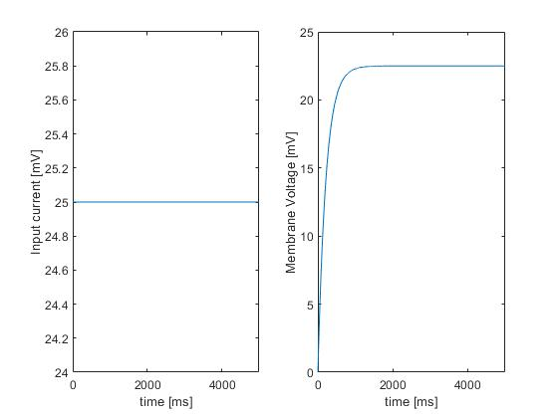

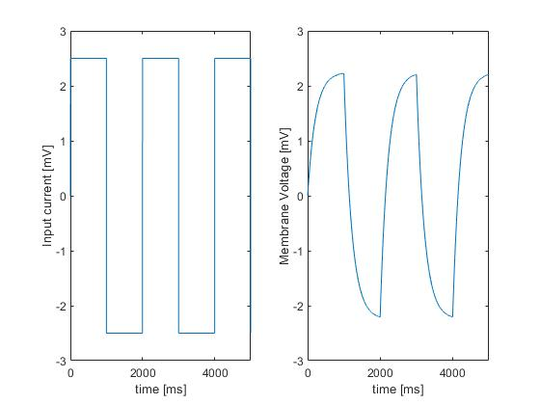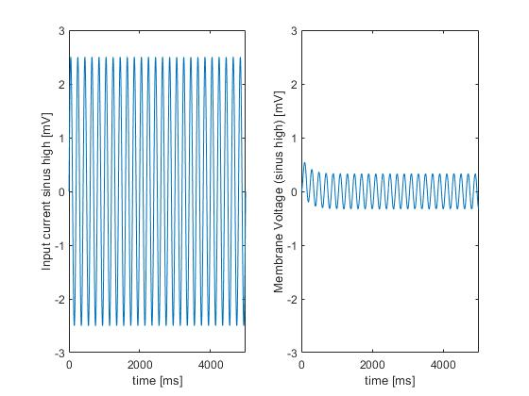Figure 1 shows that with a constant input current over time, membrane potential increases until it reaches its equilibrium potential.

Figure 2 & 3 above shows that membrane potential changes proportionally to the changes in input current. The above figures show this for both an alternating step current and sinus wave.

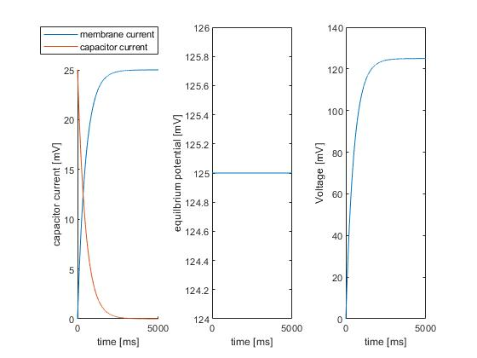

Figure 4 shows the inverse relationship between membrane current (Im) and capacitor current (Ic). Additionally, In this example equilibrium potential stays constant because it is proportional to the resistance and current, which are also constant in this example.